

Project 3: Nonlinear Programming

**Newsvendor Model: Production & Pricing Optimization**

**Group 29 Members:**

Twinkle Panda: tp26545

Anjali Pillai: ap66745

Aditya Sindhavad: aks5253

Areeba Shah: as235948

Medha Nalamada: mrn789

**Table of Contents**

1. Problem Overview 3
2. Methodology
   1. Initial Data Preparation 3
   2. Extension 1: Production Changed Optimization 5
   3. Extension 2: Quadratically Constrained Program 7
   4. Bootstrapped Sensitivity Analysis 8
3. Findings
   1. Regression & Standard NVM Analysis 9
   2. Extension 1 Analysis 10
   3. Extension 2 Analysis 11
   4. Sensitivity Analysis Results 11
4. Evaluation
   1. Model Comparison 13
   2. Challenges and Takeaways 13
5. Conclusion 14

**Problem Overview**

This project examines the application of the newsvendor model, a foundational technique of operations management that addresses the challenge of managing uncertain demand for perishable or time-sensitive products. The primary goal is to determine the optimal production quantities and pricing strategies that maximize expected profits while accounting for real-world constraints. Expanding upon the traditional newsvendor framework, this analysis integrates additional factors such as the correlation between price and demand, the cost implications of rush orders, and the penalties associated with excess inventory disposal. These enhancements aim to provide a more comprehensive and practical approach toward printing decisions for our publishing company, and our analysis can be used to maximize revenue further, increase margins, or eliminate waste.

**Methodology**

Initial Data Preparation

The data used for our model is a .CSV file of price and demand data. It consists of two variables: price and demand, where each row represents an observation of the demand level at a specific price point. This dataset serves as the foundation for setting up the NVM, where the objective is to determine the production quantity 𝑞 that maximizes expected profits under uncertain demand. The NVM assumes demand is random and follows a certain distribution, which is modeled using the observations in the dataset. Instead of relying on the true distribution of demand 𝐷, which is often unknown, we utilize the historical demand data to estimate 𝐷 to formulate our objective as:

Where is the selling price, 𝐷 is the random demand for the product and is the manufacturing cost. For computational simplicity, we reformulated this nonlinear objective into a linear programming problem defined as:

The model introduces dummy variables to linearize the profit calculation to address the nonlinearity introduced from the original function. These variables represent the profit for each observation day, constrained by either or , depending on whether demand exceeds or falls short of production.

To implement the NVM model, we can use the data set to estimate the relationship between price and demand through regression modeling. By fitting a linear regression, the demand distribution can be used for further analysis and give insights into the existing price-demand relationship.

*Figure 1: Linear Regression* 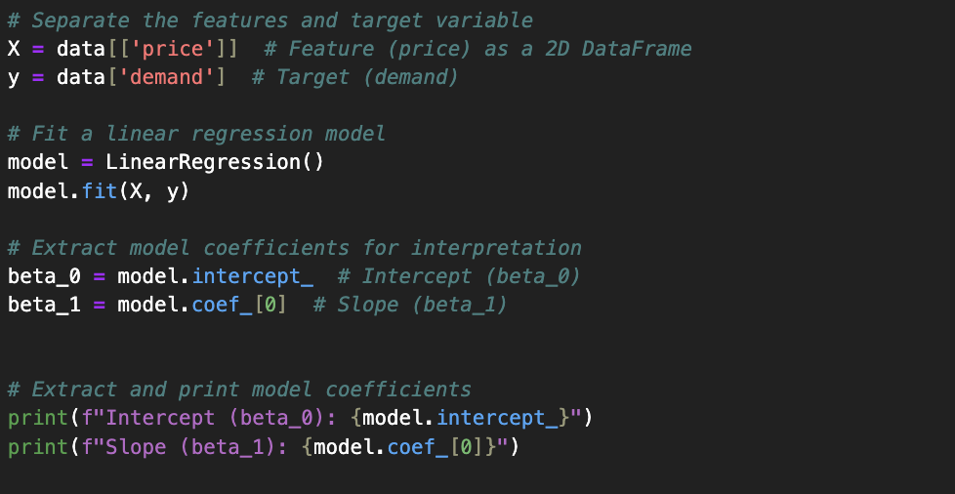

Using the residuals from the regression will allow us to simulate demand values by adding the residuals to the predicted demand for a fixed price 𝑝 = 1. This ensures that the generated demand reflects both the underlying price-demand relationship and the inherent randomness observed in the data. It simplifies the process of generating demand data while allowing us to evaluate the model's performance at a specific price point. For the standard NVM model, we can use the generated demand data from the linear regression to find the optimal production quantity at a fixed price.

*Figure 2: Optimal Quantity at Price = 1 (Standard NVM)*

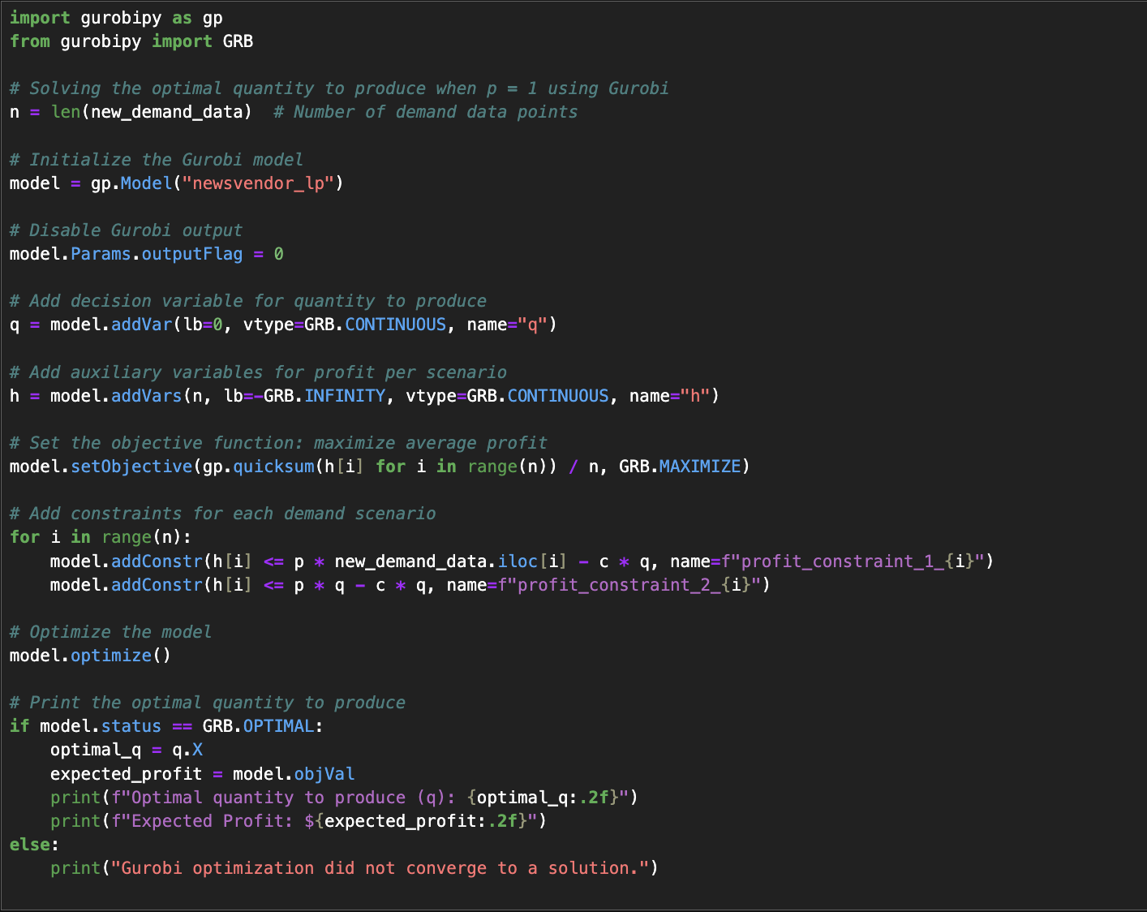

Extension 1: Production Changed Optimization

Our analysis aims to extend the original NVM model to incorporate different scenarios for our publishing company. In the first extension of our model, we introduce additional real-world considerations to account for the costs associated with underproduction and overproduction. If the production quantity is insufficient to meet demand, we assume that the shortfall can be addressed through rush orders at an additional cost per unit, denoted as 𝑔 where 𝑔 > 𝑐 (the regular manufacturing cost per unit). Conversely, if production exceeds demand, we impose a disposal fee of 𝑡 dollars per unit for the excess inventory. In some cases, the disposal fee 𝑡 could even be negative (i.e., 𝑡 < 0), representing revenue gained from recycling or other excess management strategies. However, for the purpose of this model, we will assume 𝑡 > 0, focusing on the cost implications of surplus production. Incorporating these factors, the objective function is extended to account for the combined effects of demand variability, rush order costs, and disposal fees:

where =

Similar to our initial linear reformulation, we can rewrite this objective as follows:

0

In this formulation, to account for overproduction and underproduction, two auxiliary variables are introduced: ​, represents the maximum excess production (), and , represents the shortfall in meeting demand (). These variables are constrained to be non-negative to ensure they only capture the relevant positive deviations and represent the max function from the original objective ( and ). The profit constraint incorporates revenue (), production cost (), additional costs for shortfalls with the rush order costs (), and disposal costs for excess (). By including these terms, the formulation captures the real-world trade-offs between meeting demand, over-producing, and under-producing.

*Figure 3: Optimal Quantity at Price = 1 (Extension 1)*

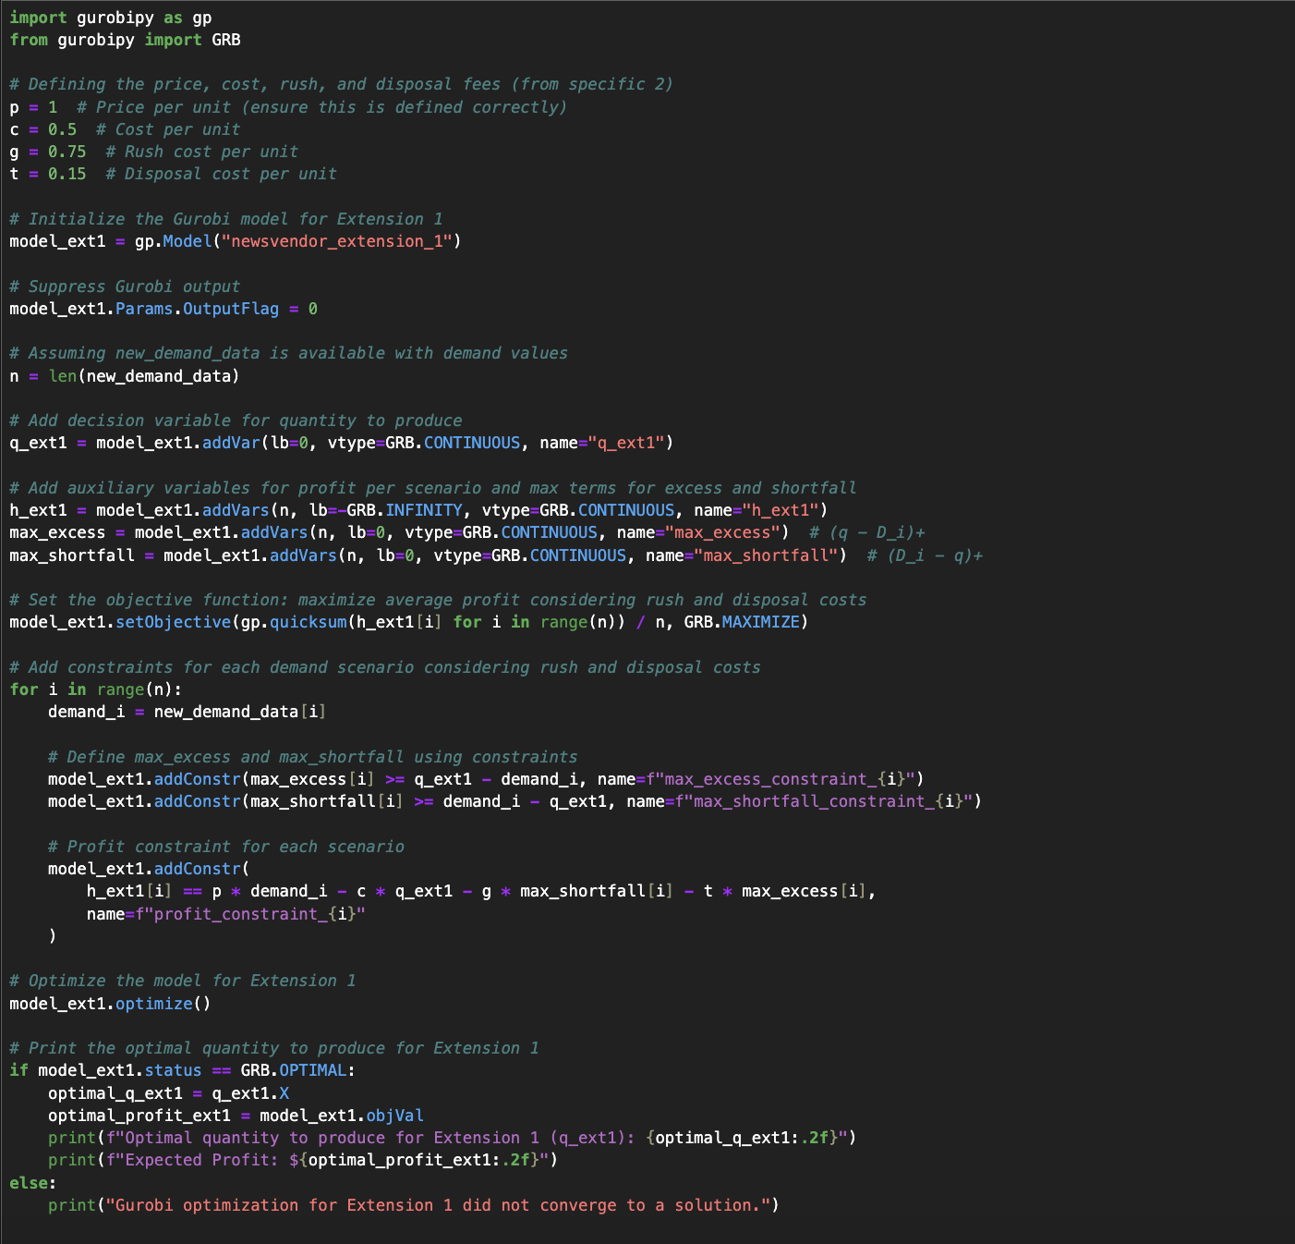

Extension 2: Price and Quantity Optimization: Quadratically Constrained Program

Another extension we explored included the assumption that demand depends linearly on price with some random variation. This is modeled as , where and are coefficients obtained from the linear regression, is the price, and represents the residuals from the regression. By incorporating this relationship, we can jointly optimize both the price and production quantity to maximize profits. Using the residuals, we generated simulated demand values for any chosen price, allowing for a more dynamic and realistic approach. Our objective function and constraints are exactly the same as they were in Extension 1, but now linearly changing, making all our constraints quadratic in :

0

This formulation now includes price as a decision variable, and our team used the Gurobi software (used in all previous explorations) to solve this QCP.

*Figure 4: Quadratically Constrained Program (QCP) - Extension 2*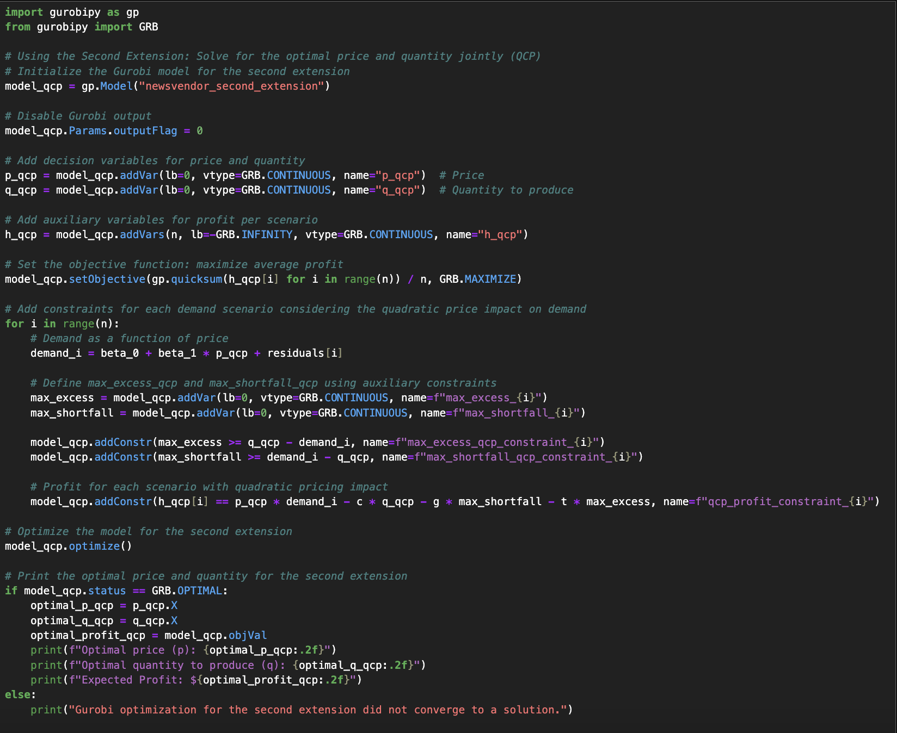

Bootstrapped Sensitivity Analysis

We expanded our research to include a sensitivity analysis that would further benefit the publishing company by allowing them to evaluate how variations in the dataset could affect the optimal price, production quantity, and resulting profits. This was done to reflect a more realistic scenario since demand, price, and costs are often dynamically changing. By conducting a sensitivity analysis, we aimed to understand the stability of these production decisions and their effects on the company’s profit. To achieve this, we used bootstrap resampling to generate multiple variations of the original dataset, capturing a wide range of potential scenarios. This involves creating new datasets by randomly selecting data points from the original dataset, allowing some points to be repeated. Each new dataset represents a slightly altered version of the original, effectively mimicking how real-world data might vary. For each bootstrap sample, we refit the regression model to derive new coefficients ( and ), simulated demand values using these updated coefficients, and solved the Quadratically Constrained Program (QCP) to determine the optimal price and quantity. By repeating this process across numerous iterations, we obtained a distribution of optimal price, quantity, and profits, providing insights into the variability of these key outputs. This analysis not only highlights the impact of dataset variation but also strengthens the credibility of our recommendations by identifying potential ranges for pricing and production decisions.

*Figure 5: Bootstrap Resampling to Generate New Demand*  
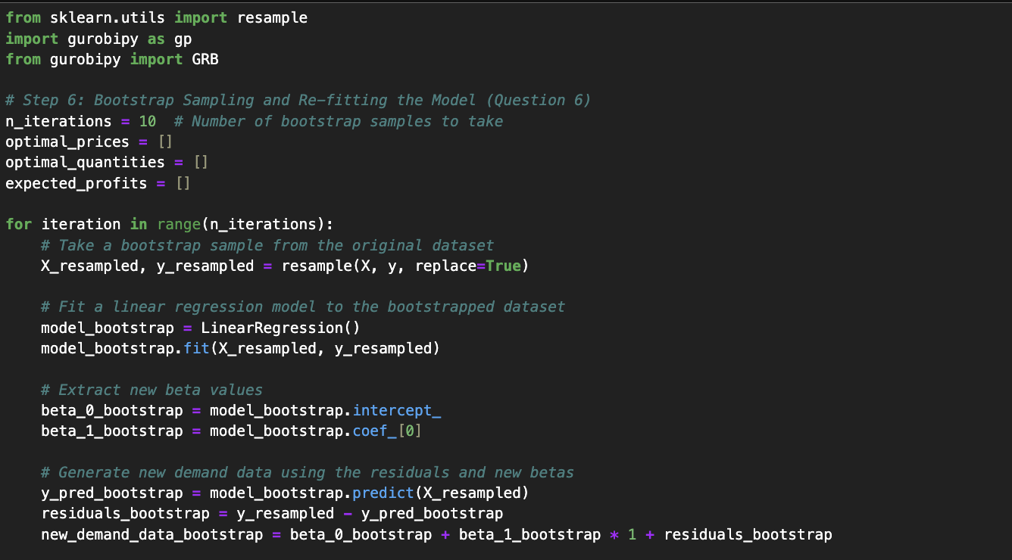

Initially, we iterated over 10 bootstrap samples, with each iteration generating random samples of price and demand to find new coefficients. The QCP optimization was performed on each set of new demand data to find the optimal prices for that specific iteration and later appended to a list of prices and quantities that stored the combinations of each variable after all iterations of samples.

*Figure 6: QCP for Each Sample*

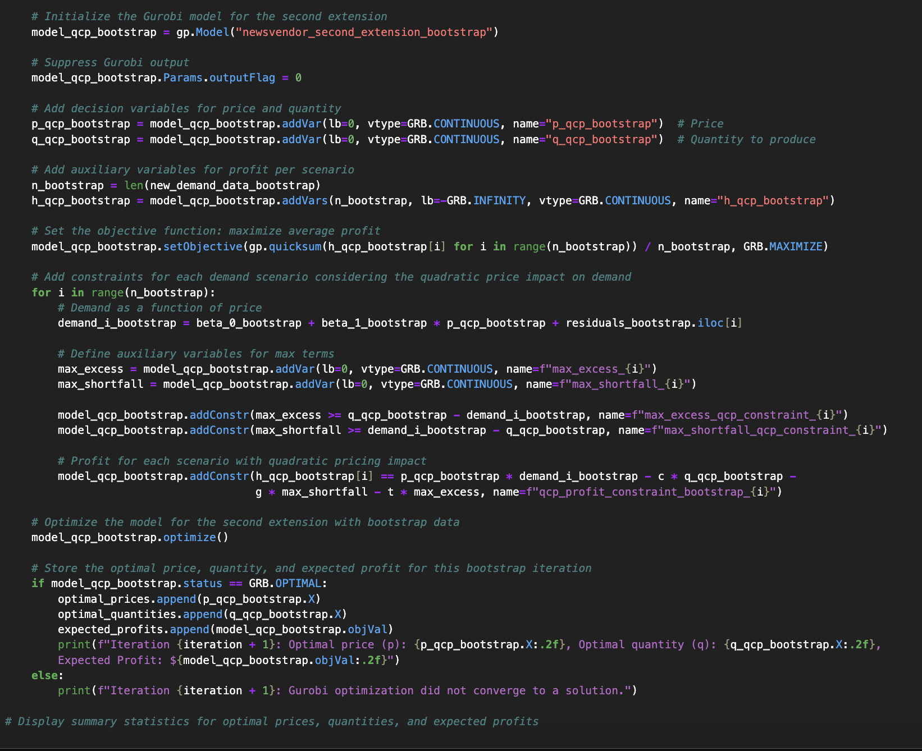

**Findings**

Through our analysis, we aimed to uncover how variations in data and model assumptions impact the optimal price, production quantity, and overall profitability. By systematically exploring different scenarios, we gained insights into the robustness of our model and its practical implications. The following sections present the key results from our optimization explorations and sensitivity analysis, highlighting patterns and trends that can further assist the publishing company in making operational decisions.

Regression & Standard NVM Analysis

As explained in our methodology, we initially performed a linear regression to estimate the demand function needed to perform the optimization.

*Figure 7: Linear Regression Results*

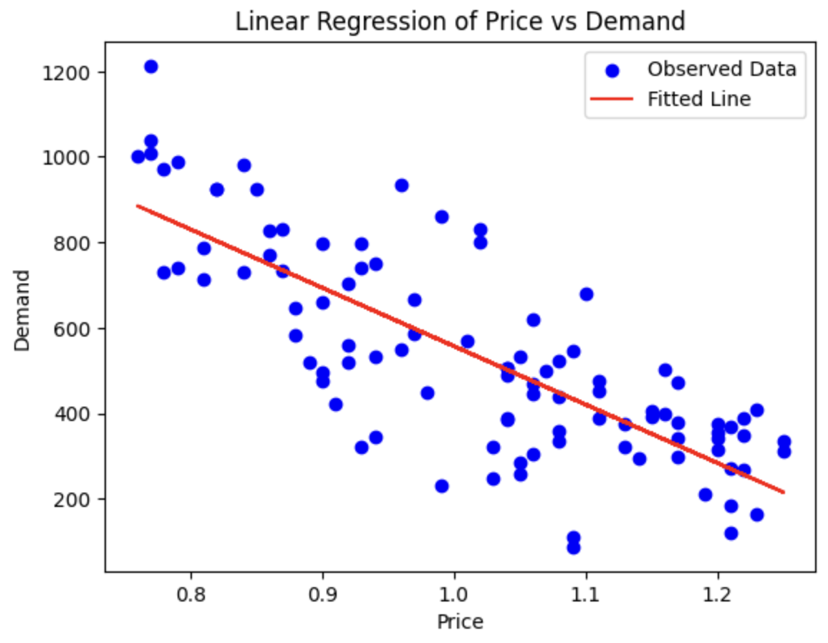

The regression analysis highlights the expected clear negative relationship between price and demand, as evident from the downward slope of the fitted line in Figure 1. The model solved for = 1924.72 and = -1367.71 and the residuals were used to calculate the demand data needed for the standard NVM model. Initially, the selling price was fixed at $1 while the cost per unit was set at = 0.5, and the optimal quantity was found after performing the Gurobi optimization.

| **Model** | **Optimal Quantity (units)** | **Profit ($)** |
| --- | --- | --- |
| Standard NVM | 569.9 | $219.28 |

This initial analysis of the standard NVM establishes a strong foundation by determining the optimal production quantity and profit when the selling price is fixed. However, this model is oversimplified for actual operations management. Real-world scenarios often involve additional complexities, such as costs associated with underproduction or overproduction. To address these practical challenges, the first extension of the model incorporated rush order costs for shortfalls and disposal fees for surplus production. In the next section, we explore this extension and its impact on the optimal production strategy and profitability.

Extension 1 Analysis

To analyze the effect of including changing production strategies to meet demand, we fixed the cost per rushed order at a value higher than the original cost at = 0.75, to mimic the expectation that an instantaneous order will be more expensive for the company to produce. We also set the cost of disposal at = 0.15 and extended our model to incorporate the overproduction and underproduction scenarios.

| **Model** | **Optimal Quantity (units)** | **Profit ($)** |
| --- | --- | --- |
| Extension 1 | 471.87 | $231.48 |

The results from Extension 1 reveal the significant impact of accounting for real-world costs such as rush orders and disposal fees in the Newsvendor Model. The optimal production quantity decreased from 569.89 units in the standard model to 471.87 units. Despite the lower production quantity, the profit increased from $219.00 to $231.48, highlighting the efficiency gained by incorporating these additional costs into the model. This improvement reflects the model's ability to minimize financial penalties associated with overproduction and underproduction, ultimately optimizing profitability. These results underscore the value of extending the standard model to better align with real-world production scenarios. However, this model introduces additional complexity and still maintains static price assumptions. Additionally, the model is heavily reliant on the inputs for production, rush orders, and disposal costs. If the company does not have accurate estimates, the model optimization results may be more unreliable. We can address some of these inefficiencies by introducing price as a decision variable to jointly optimize for production and pricing strategies.

Extension 2 Analysis

Our previous explorations were all performed under the assumption that the price was fixed. However, realistically, we can improve the NVM to acknowledge the direct relationship between price and demand, modeled as a linear function with random variation. By introducing this dependency, the problem evolved into a Quadratically Constrained Program (QCP) with the following results:

| **Model** | **Optimal Quantity (units)** | **Optimal Price ($)** | **Profit ($)** |
| --- | --- | --- | --- |
| Extension 2 | 535.31 | 0.954 | $234.42 |

By incorporating the linearly changing relationship between price and demand, the model identifies a pricing strategy that maximizes revenue while minimizing the penalties associated with overproduction and underproduction. Compared to Extension 1, where the price was fixed and only production quantity was optimized, this approach provides a more flexible and realistic framework for decision-making that further improves profits by a small margin. The ability to adjust price based on demand elasticity introduces a new layer of efficiency, resulting in an optimized balance between revenue, production costs, and additional penalties. This extension, however, may be much more costly for the company to implement since it requires more sophisticated solvers and computational resources. The model is also reliant on the input data, so if the generated demand data is noisy or uncertain, the results could be subject to greater volatility.

Sensitivity Analysis Results

While the QCP model provides optimized price and quantity decisions based on the given dataset, it is important to evaluate how robust these results are to variations in the underlying data. Sensitivity analysis was conducted to assess how changes in the dataset impact the optimal price, production quantity, and resulting profits. By applying bootstrap sampling, we generated multiple variations of the dataset and re-solved the QCP for each, allowing us to explore the distribution of the model's outputs. We visualized our results with histograms and scatter plots to represent the variability of optimal price, quantity, and expected profit.

*Figure 8: Sensitivity Analysis Histograms*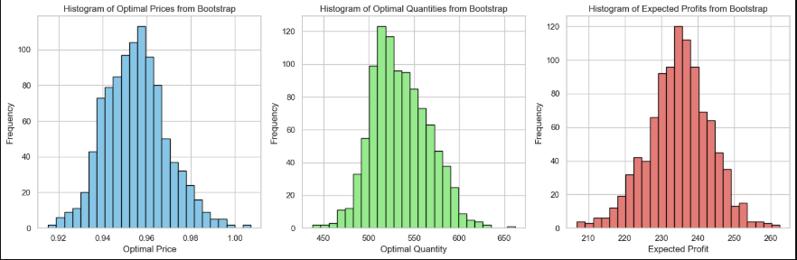

*Figure 9: Sensitivity Analysis Scatterplot*

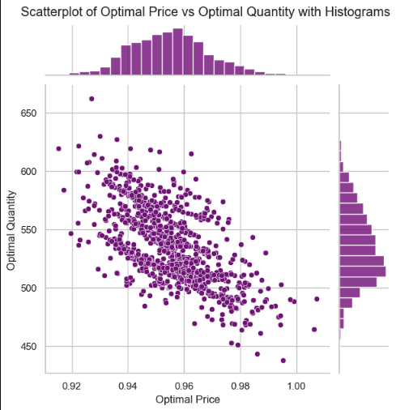

The histogram of optimal prices shows that most values fall between 0.94 and 0.97, indicating that the model's pricing decisions are relatively stable, with only a few outliers. The optimal quantities histogram, on the other hand, shows a wider range, with values primarily clustering between 500 and 560 units, indicating that quantity choices are marginally more sensitive to dataset fluctuations. According to the predicted earnings histogram, the majority of values fall between $230 and $245, with a small number rising to $250. This suggests that the overall profitability stays constant during iterations. Because of the price-demand relationship, higher prices typically translate into lower production volumes, as seen by the scatterplot of optimal price vs quantity, which shows a modest negative association. The durability of the model under various data scenarios is demonstrated by these results, which show that although production quantity is somewhat sensitive to data variability, pricing decisions, and overall profitability remain steady.

**Evaluation**

Model Comparison

| **Model** | **Optimal Quantity (units)** | **Optimal Price ($)** | **Profit ($)** |
| --- | --- | --- | --- |
| Standard NVM | 569.9 | 1 (fixed) | $219.28 |
| Extension 1- Rush Disposal | 471.87 | 1 (fixed) | $231.48 |
| Extension 2 - Price Impact Demand | 535.31 | 0.954 | $234.42 |
| Standard NVM | 469.00 | dynamic | $167.64 |

The comparison of the three models provides valuable insights for the publishing company. The Standard NVM serves as a strong foundation, offering a straightforward strategy when pricing is fixed and demand is predictable. However, its assumptions of ideal conditions limit its real-world applicability, as it generates the lowest profit among the models at $219.28. In the real world, unexpected shifts in demand and additional costs, such as rush printing or disposal fees for unsold copies, often impact profitability. Extension 1 addresses these challenges, showing that accounting for such costs can lead to a more conservative production strategy, which reduces quantity but increases profit to $231.48. Extension 2 goes further by incorporating dynamic pricing, which allows for adjustments to production levels and pricing in response to market conditions or expected demand. This approach achieves the highest profit of $234.42, illustrating the potential of fine-tuned strategies to maximize revenue while maintaining operational efficiency. In order to maintain a balance between profitability and adaptability, publishers might utilize this strategy to adjust to changes in demand brought on by events such as breaking news, seasonal trends, or competition. These results highlight the importance of moving beyond a fixed-price model to incorporate cost concerns and flexible pricing strategies into production planning, enabling publishers to stay competitive in a changing market.

Challenges & Takeaways

While implementing this model can be extremely efficient and beneficial for the publishing company, there are some potential limitations to consider. First, the accuracy of the model heavily depends on the quality and reliability of the data used, particularly for estimating the price-demand relationship and associated costs such as rush orders and disposal fees. Inaccurate data or incorrect assumptions could lead to suboptimal decisions. Additionally, the computational complexity of the extended models, particularly the QCP, may require advanced resources, which could pose a barrier for smaller publishers. Furthermore, the dynamic nature of market conditions, such as changing consumer behavior or competitive pricing, might reduce the model's applicability over time if it is not consistently updated. Despite these challenges, the key takeaway is that integrating realistic cost factors and dynamic pricing strategies into production planning provides a more adaptable and profitable framework. Addressing these limitations through robust data collection, regular updates, and proper resource allocation, the publishing company can significantly enhance its operational efficiency and profitability.

**Conclusion**

Overall, our analysis demonstrates that moving beyond the standard NVM model is essential for the company to make more informed and profitable printing decisions. By switching from the standard model depending on the requirements, our exploration offered various other solutions that will be holistically better for the company. These extensions accounted for real-world factors such as rush order costs, disposal fees, and dynamic pricing, leading to higher profitability and operational flexibility. The sensitivity analysis also provided an extensive range of options that the company could target, leading to more efficient decision-making. Future enhancements could also be incorporated into the model, where the sensitivity analysis could also be extended to a varying range of costs to demonstrate the impact of lower or higher costs of disposal or rush orders. In conclusion, this holistic approach positions the company to remain more adaptable and competitive in a rapidly changing publishing industry.